Modelos dinámicos

J. Ramajo

2020

library(readr)  
library(dynlm)

library(car)

library(lmtest)  
library(sandwich)  
library(orcutt)

#  
TIPOS_ESP <- read_csv("TIPOS_ESP.csv")

## Parsed with column specification:  
## cols(  
## R3M = col_double(),  
## RD = col_double(),  
## RL = col_double()  
## )

TIPOS_ESP_ts <- ts(TIPOS_ESP, start=c(1982,1), end = c(1990,3), frequency = 4)  
plot(TIPOS_ESP_ts)

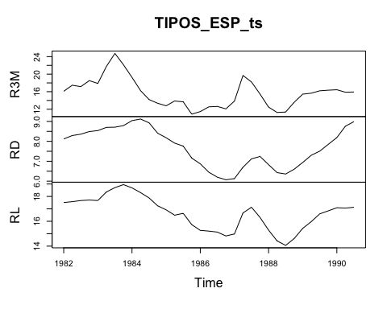

#  
RL <- TIPOS_ESP_ts[,"RL"]  
R3M <- TIPOS_ESP_ts[,"R3M"]   
RD <- TIPOS_ESP_ts[,"RD"]  
#  
S(lm_KM <- lm(RL ~ R3M + RD))

## Call: lm(formula = RL ~ R3M + RD)  
##   
## Coefficients:  
## Estimate Std. Error t value Pr(>|t|)   
## (Intercept) 7.02728 0.48653 14.444 1.43e-15 ***  
## R3M 0.15918 0.02301 6.918 7.84e-08 ***  
## RD 0.92600 0.07777 11.907 2.69e-13 ***  
## ---  
## Signif. codes: 0 '***' 0.001 '**' 0.01 '*' 0.05 '.' 0.1 ' ' 1  
##   
## Residual standard deviation: 0.3567 on 32 degrees of freedom  
## Multiple R-squared: 0.9322  
## F-statistic: 219.9 on 2 and 32 DF, p-value: < 2.2e-16   
## AIC BIC   
## 32.03 38.25

#  
# Modelo ARDL(0,0,0) -estático-

#  
S(dynlm_KM_0 <- dynlm(RL ~ R3M + RD))

## Call: dynlm(formula = RL ~ R3M + RD)  
##   
## Coefficients:  
## Estimate Std. Error t value Pr(>|t|)   
## (Intercept) 7.02728 0.48653 14.444 1.43e-15 ***  
## R3M 0.15918 0.02301 6.918 7.84e-08 ***  
## RD 0.92600 0.07777 11.907 2.69e-13 ***  
## ---  
## Signif. codes: 0 '***' 0.001 '**' 0.01 '*' 0.05 '.' 0.1 ' ' 1  
##   
## Residual standard deviation: 0.3567 on 32 degrees of freedom  
## Multiple R-squared: 0.9322  
## F-statistic: 219.9 on 2 and 32 DF, p-value: < 2.2e-16   
## AIC BIC   
## 32.03 38.25

# Contrastes de correlación serial (autocorrelación)  
#  
# Correlograma  
r <-residuals(dynlm_KM_0)  
plot(r)  
abline(h=0, lty=2)

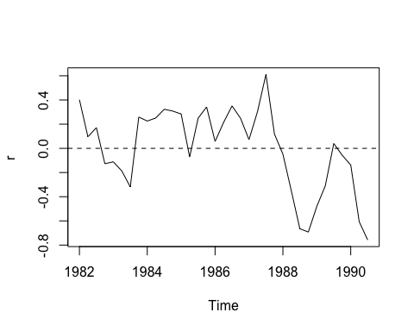

corr <- acf(r)

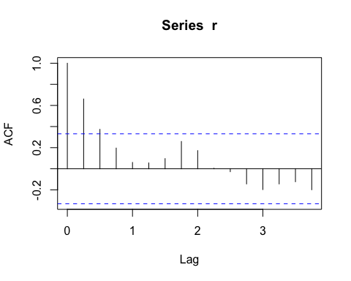

corr$acf[2:10]

## [1] 0.661182301 0.373478408 0.196080083 0.059991302 0.055270320 0.096234644  
## [7] 0.258730586 0.172078454 0.005038669

# Test de Durbin-Watson  
dwtest(dynlm_KM_0, alternative = "two.sided")

##   
## Durbin-Watson test  
##   
## data: dynlm_KM_0  
## DW = 0.49682, p-value = 9.951e-09  
## alternative hypothesis: true autocorrelation is not 0

dwtest(dynlm_KM_0, alternative = "greater")

##   
## Durbin-Watson test  
##   
## data: dynlm_KM_0  
## DW = 0.49682, p-value = 4.976e-09  
## alternative hypothesis: true autocorrelation is greater than 0

# Test de Breusch-Godfrey  
bgtest(dynlm_KM_0, order=1, type="Chisq", fill=0)

##   
## Breusch-Godfrey test for serial correlation of order up to 1  
##   
## data: dynlm_KM_0  
## LM test = 18.689, df = 1, p-value = 1.539e-05

#  
# Corrección de la autocorrelación: MCO corregidos, MCG-AR, modelos ARDL  
#  
# Errores estándar robustos, HAC (Newey-West)  
S(dynlm_KM_0 <- dynlm(RL ~ R3M + RD), vcov.=vcovHAC(dynlm_KM_0))

## Call: dynlm(formula = RL ~ R3M + RD)  
## Standard errors computed by vcovHAC(dynlm_KM_0)   
##   
## Coefficients:  
## Estimate Std. Error t value Pr(>|t|)   
## (Intercept) 7.02728 0.66475 10.571 5.72e-12 ***  
## R3M 0.15918 0.03572 4.457 9.56e-05 ***  
## RD 0.92600 0.11776 7.863 5.69e-09 ***  
## ---  
## Signif. codes: 0 '***' 0.001 '**' 0.01 '*' 0.05 '.' 0.1 ' ' 1  
##   
## Residual standard deviation: 0.3567 on 32 degrees of freedom  
## Multiple R-squared: 0.9322  
## F-statistic: 146.4 on 2 and 32 DF, p-value: < 2.2e-16   
## AIC BIC   
## 32.03 38.25

# Mínimos cuadrados generalizados (MCG): errores AR(1)  
cochrane.orcutt(dynlm_KM_0)

## Cochrane-orcutt estimation for first order autocorrelation   
##   
## Call:  
## dynlm(formula = RL ~ R3M + RD)  
##   
## number of interaction: 11  
## rho 0.773176  
##   
## Durbin-Watson statistic   
## (original): 0.49682 , p-value: 4.976e-09  
## (transformed): 1.69696 , p-value: 1.308e-01  
##   
## coefficients:   
## (Intercept) R3M RD   
## 7.013488 0.157823 0.913996

#

# Modelo -dinámico ARDL(1,1,1)   
#  
S(dynlm_KM_1 <- dynlm(RL ~ L(RL, 1:1) + L(R3M, 0:1) + L(RD, 0:1)))

## Call: dynlm(formula = RL ~ L(RL, 1:1) + L(R3M, 0:1) + L(RD, 0:1))  
##   
## Coefficients:  
## Estimate Std. Error t value Pr(>|t|)   
## (Intercept) 1.95931 1.02773 1.906 0.06690 .   
## L(RL, 1:1) 0.71922 0.13830 5.200 1.60e-05 ***  
## L(R3M, 0:1)0 0.16624 0.02491 6.673 3.05e-07 ***  
## L(R3M, 0:1)1 -0.07777 0.03656 -2.127 0.04237 *   
## L(RD, 0:1)0 0.65959 0.19117 3.450 0.00179 **   
## L(RD, 0:1)1 -0.48983 0.24726 -1.981 0.05748 .   
## ---  
## Signif. codes: 0 '***' 0.001 '**' 0.01 '*' 0.05 '.' 0.1 ' ' 1  
##   
## Residual standard deviation: 0.2333 on 28 degrees of freedom  
## Multiple R-squared: 0.9743  
## F-statistic: 212 on 5 and 28 DF, p-value: < 2.2e-16   
## AIC BIC   
## 4.92 15.61